Literacy  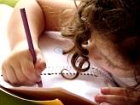 In Talk for Writing we will be exploring the Journey Tale: Little Charlie and the Lighthouse Keeper. We will be focusing on developing our use settings, similes and adverbs. For our non-fiction focus we will be writing instructions about a fictious topic such as “How to Trap an Alien”. | 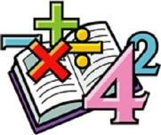  Maths  In Math we are focusing on multiplication and division. This will involve being able to identify and create equal groups as well as sharing a quantity evenly. We will be developing our use of the 2, 5 and 10 times-tables as well as working with odd and even numbers. | Science  We are learning about animals, including humans. This will involve finding out about the basic needs for survival i.e. water, food, air and shelter as well as the impact of exercise, diet and hygiene. We will explore life cycles including offspring and growth. | Computing  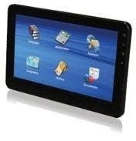  In computing we will be utilising our space topic to complete data handling related to the International Space Station. We will understand how computers can help humans survive in space as well as understand the role of sensors.
Humanities  We will be exploring the History of space travel. We will explore the timeline of significant events including the launch of the first rocket, animals in space and the landing of Apollo 11. We will focus on the space explorer and astronaut – Neil Armstrong as a significant person as well as how space exploration has changed over the years. | Overdale Community Primary School  Spring Term 1 2024  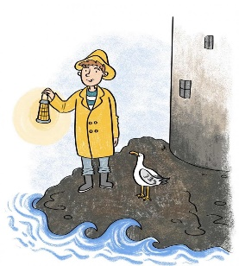  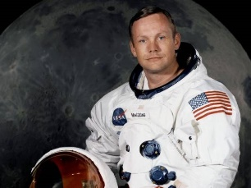 |  | PHSE  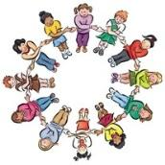  In PHSE and RSE we will be focusing on citizenship. We will be exploring the role of rules and laws in society as well as understanding the different contributions people can make to the community including jobs and volunteering. We will continue to strengthen our knowledge of the British Value democracy by exploring the School Council.
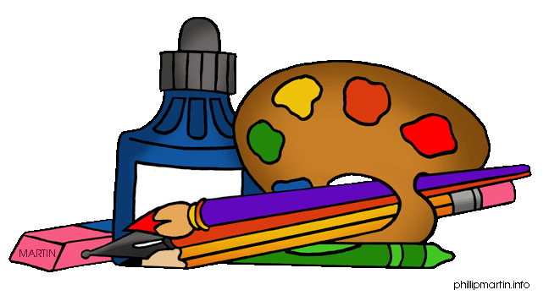  Art and DT  In Art we will be focusing on ‘exploring and drawing’. This will involve understanding how artists take their inspiration from around them, collecting and transforming. We will be using different media (sometimes combined in one drawing) to capture the nature of things we find. We will explore the work of artists Andy Goldsworthy and Van Gogh. | PE  In P.E. we will be exploring invasion games. This will involve throwing, catching and passing balls with consistency and control as well as developing spatial awareness in order to track, dodge and evade opponents. | Music In music we are exploring ‘Musical Me’ to develop our understanding of what melody, notation and accompaniment are. We will be making tunes by using high and low pitched notes played one after another. | RE In R.E. we will be thinking about how and why do we celebrate special times. This will include identifying some ways Christians celebrate Easter, Harvest, Pentecost and some ways a festival is celebrated in another religion.

